**HEAD ADMIN**

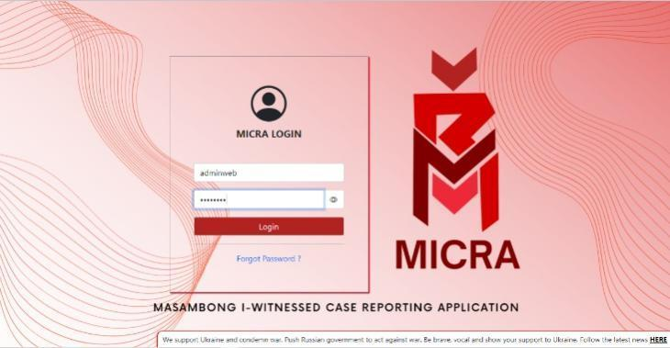

MICRA Login – There would be two text boxes, one for "username" and one for "password” –to enter admin credentials. There's also a Login button and a Forgot Password text button.

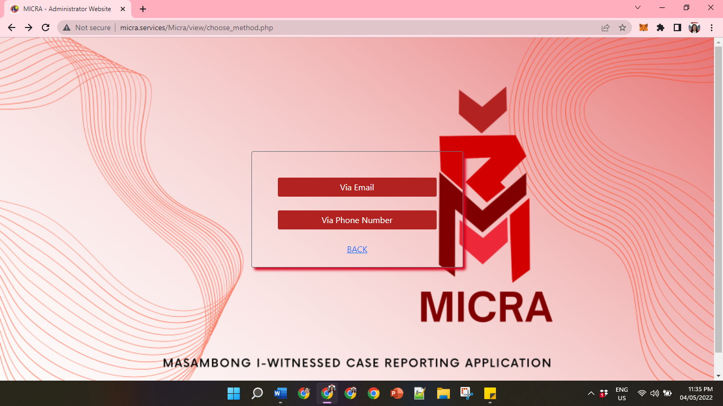

Forgot Password – There would be two (2) text boxes, one for “via Email” and one for “Via Phone Number” –it will send an OTP notification through Email or SMS to reset the main admin password.

There's also a “BACK” hyperlink button if the main admin wants to go back to the Login Module.

The MICRA will automatically create a graph based on residents' reports and updated status.

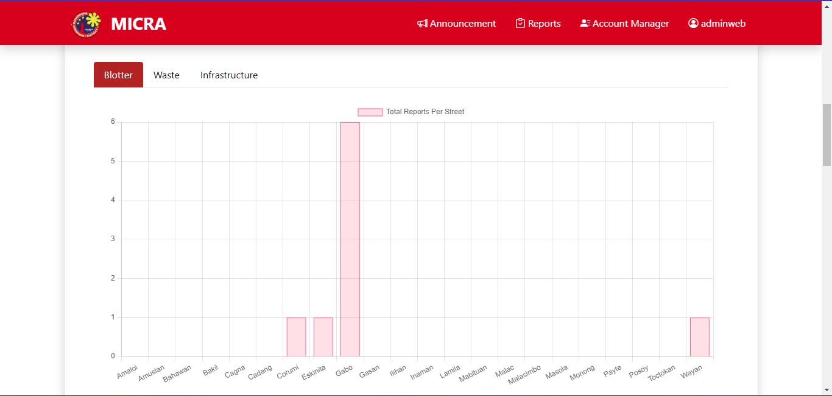

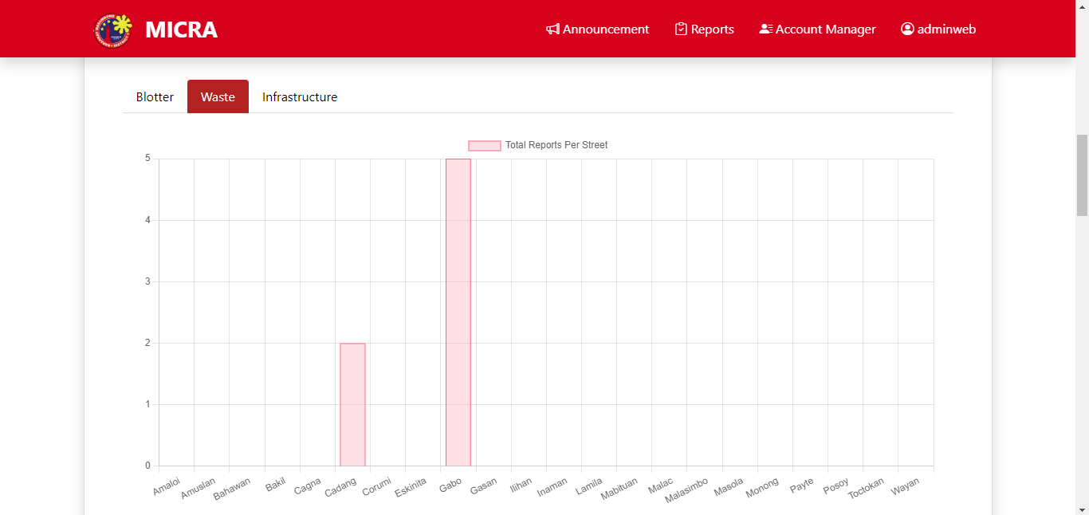

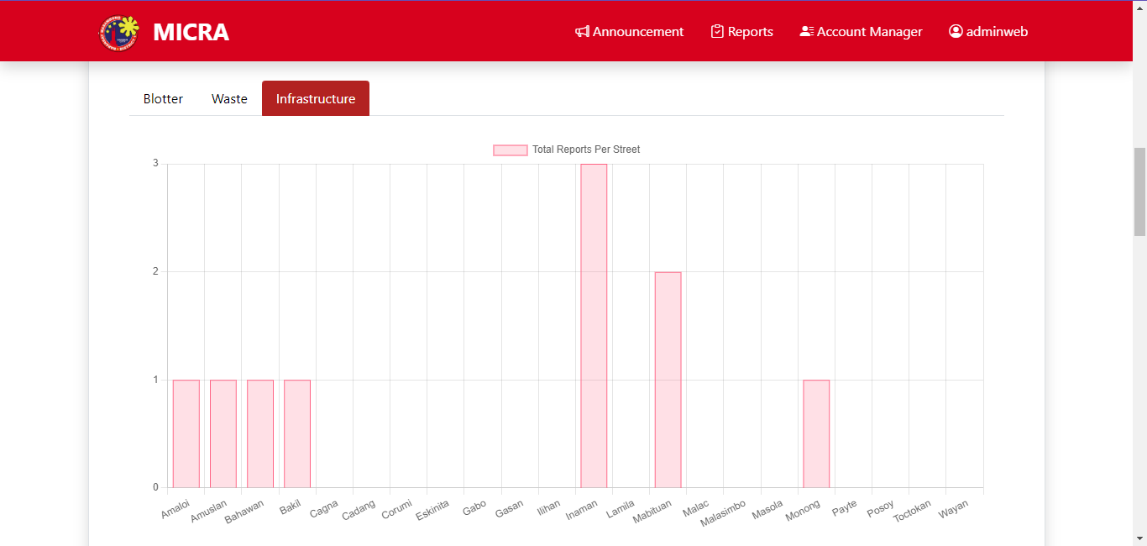

Head Admin Total Reports per Street – Head Admin will see the total number of reports per street for Blotter, Waste and Infrastructure.

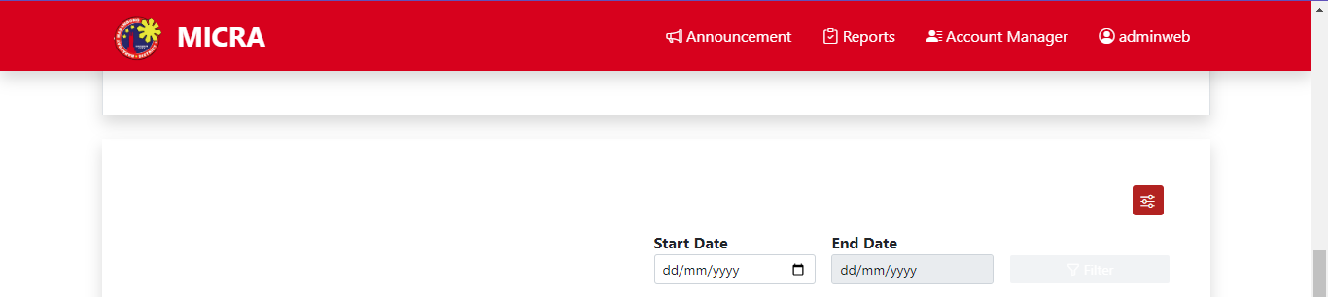

After you see the total number of reports you can also filter the reports you wanted to see.

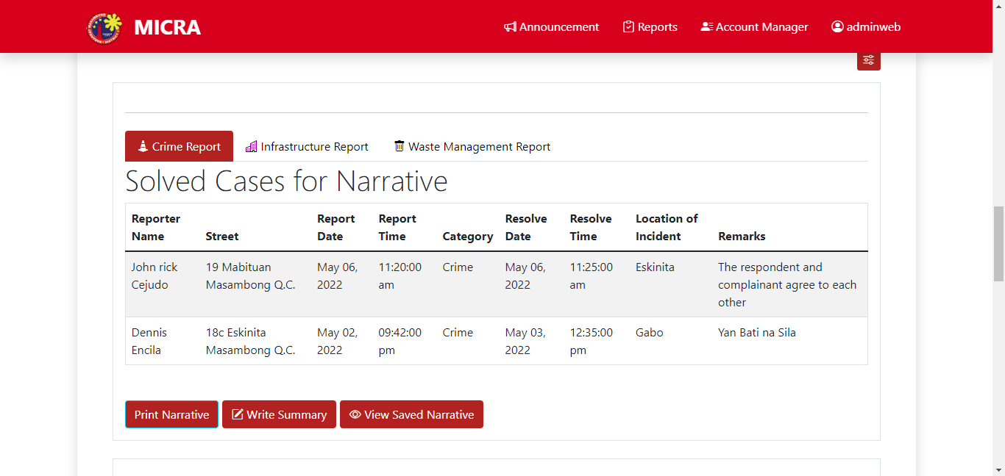

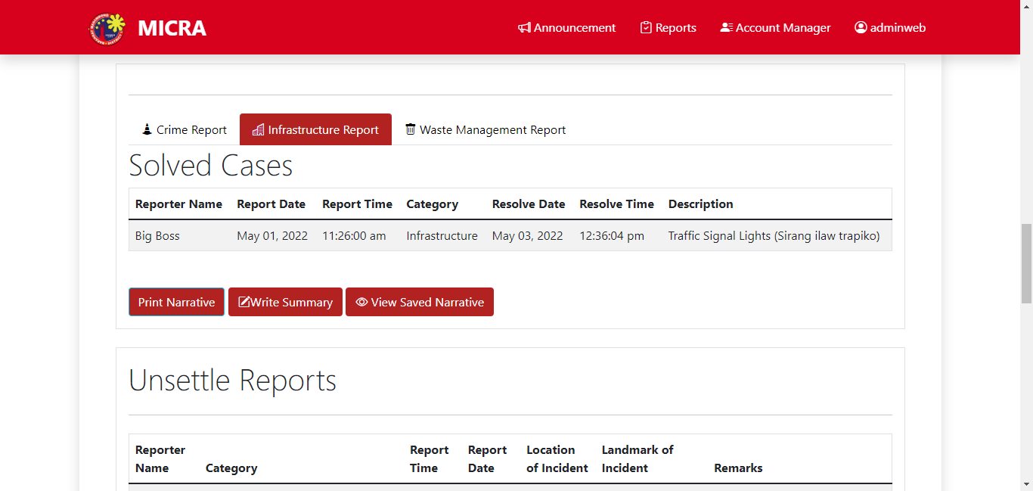

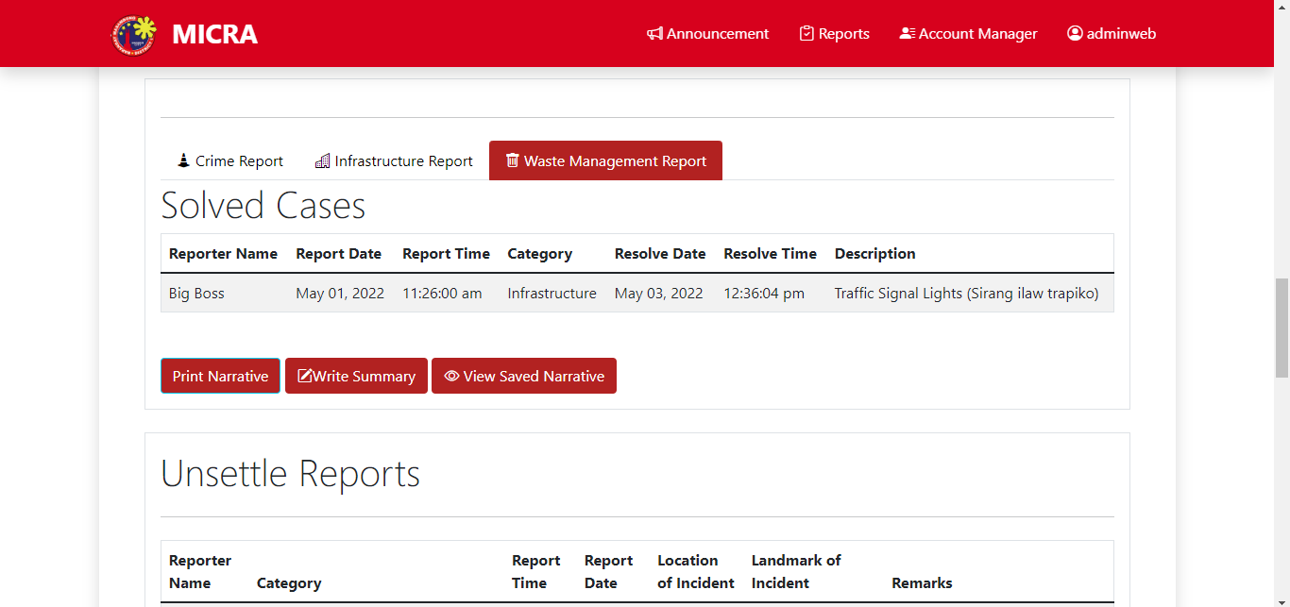

Head Admin Solved Cases for Narrative – Every tab for category will show Reporter Name, Report Date, Report Time, Category, Resolve Date, Resolve Time and Description.

Below the tabs you can see the three buttons Print Narrative, Write Summary and View Narrative.

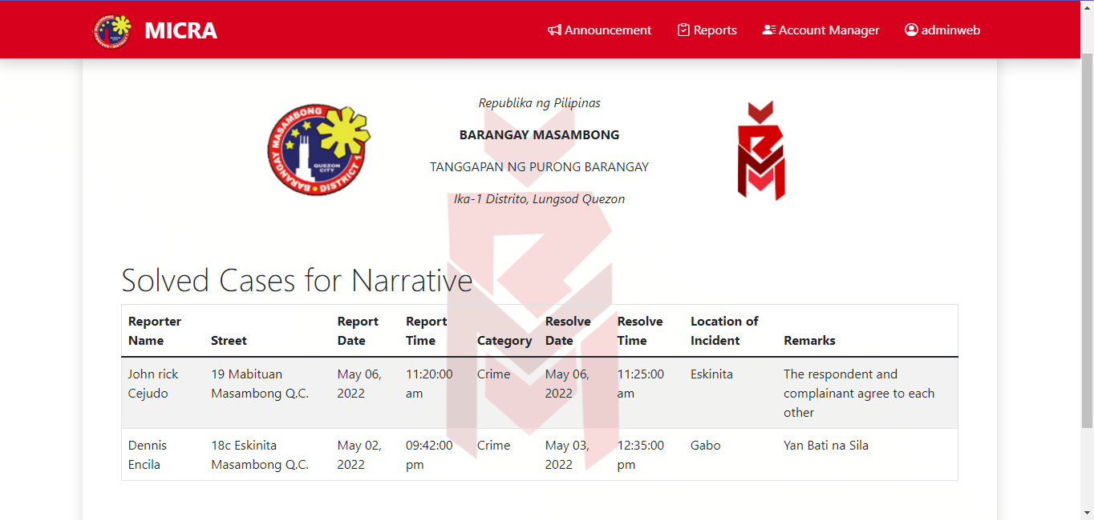

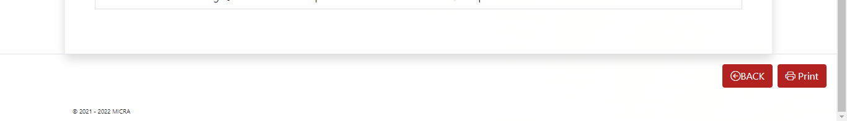

View for Print Narrative

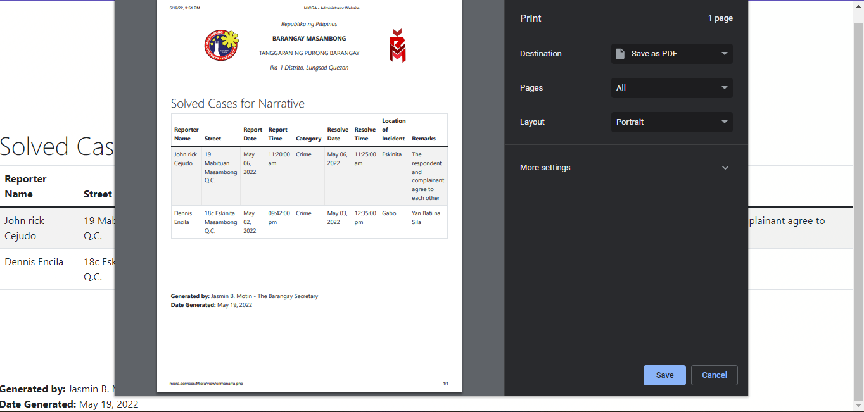

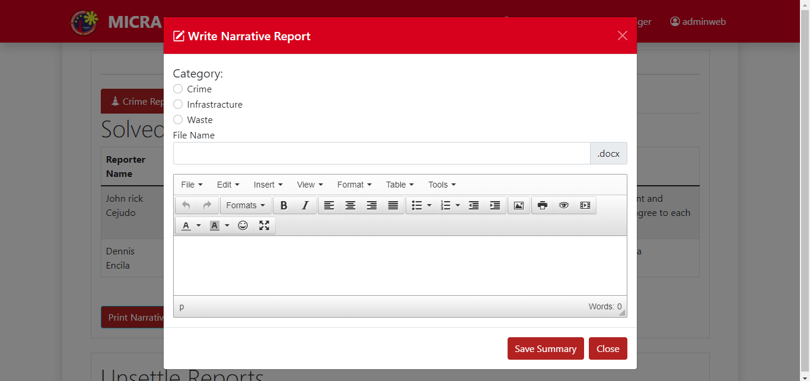

View for Write Summary

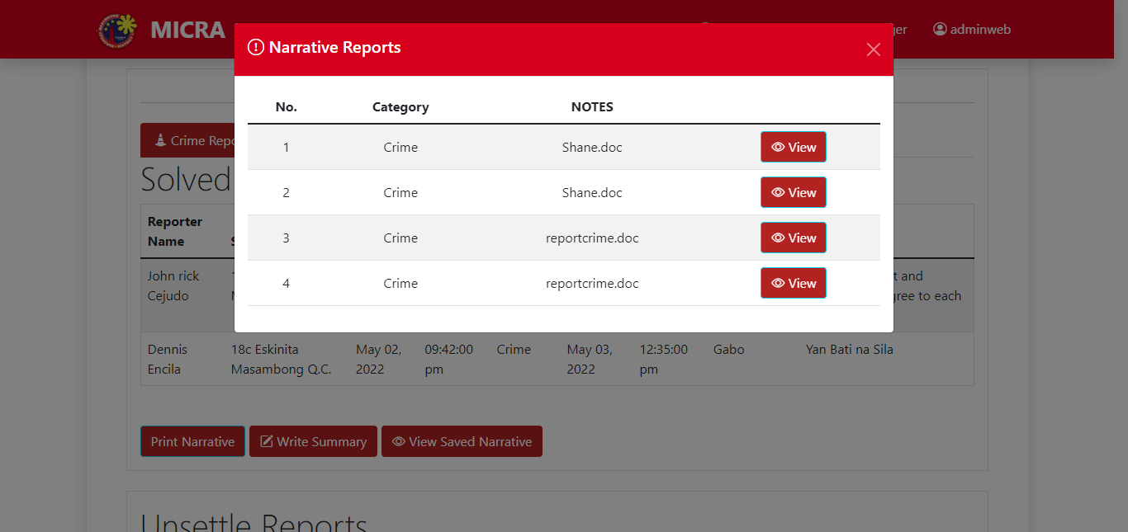

View for View Narrative

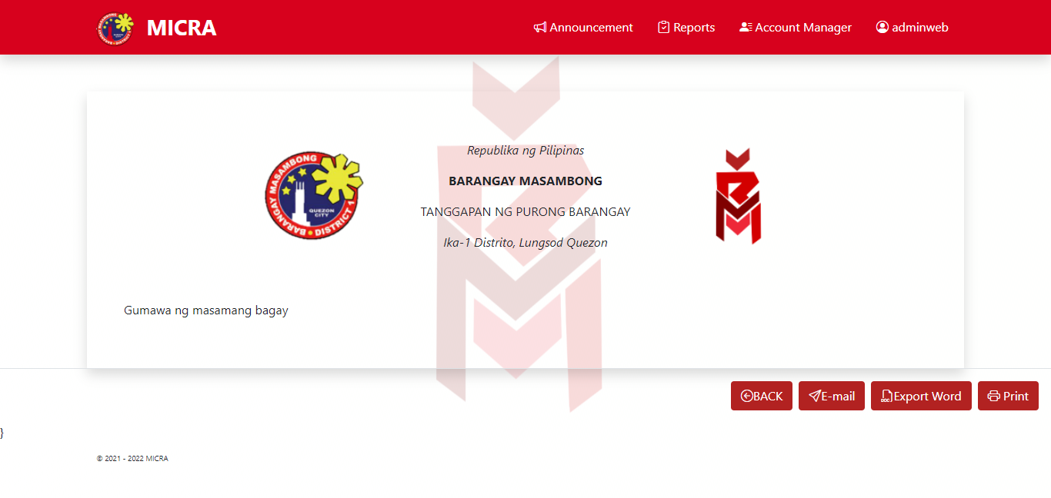

After you click the View button the Head Admin will see the four buttons which are Back, E-mail, Export Word and Print.

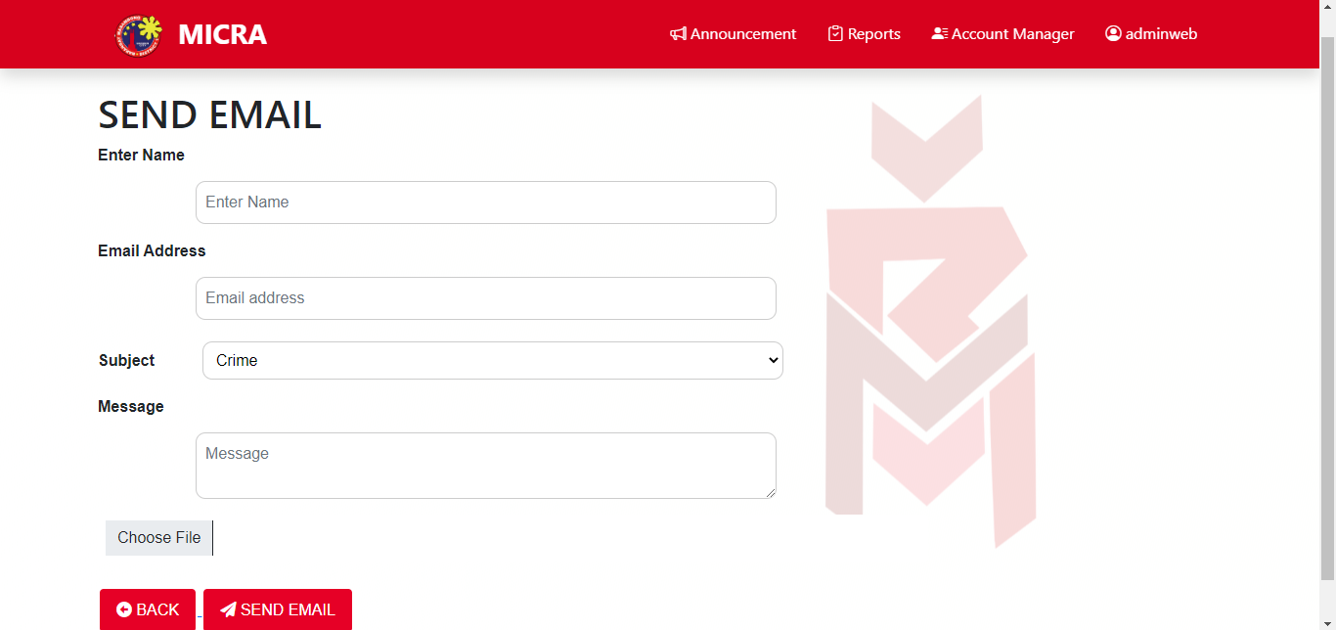

View for Email Button wherein the head admin can send email about the reports.

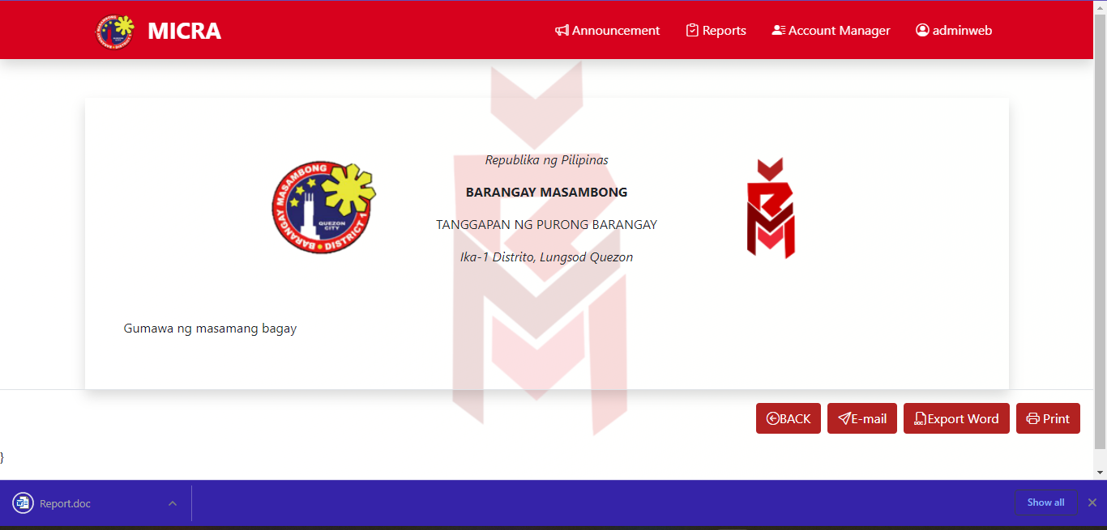

For Export words the document will automatically download.

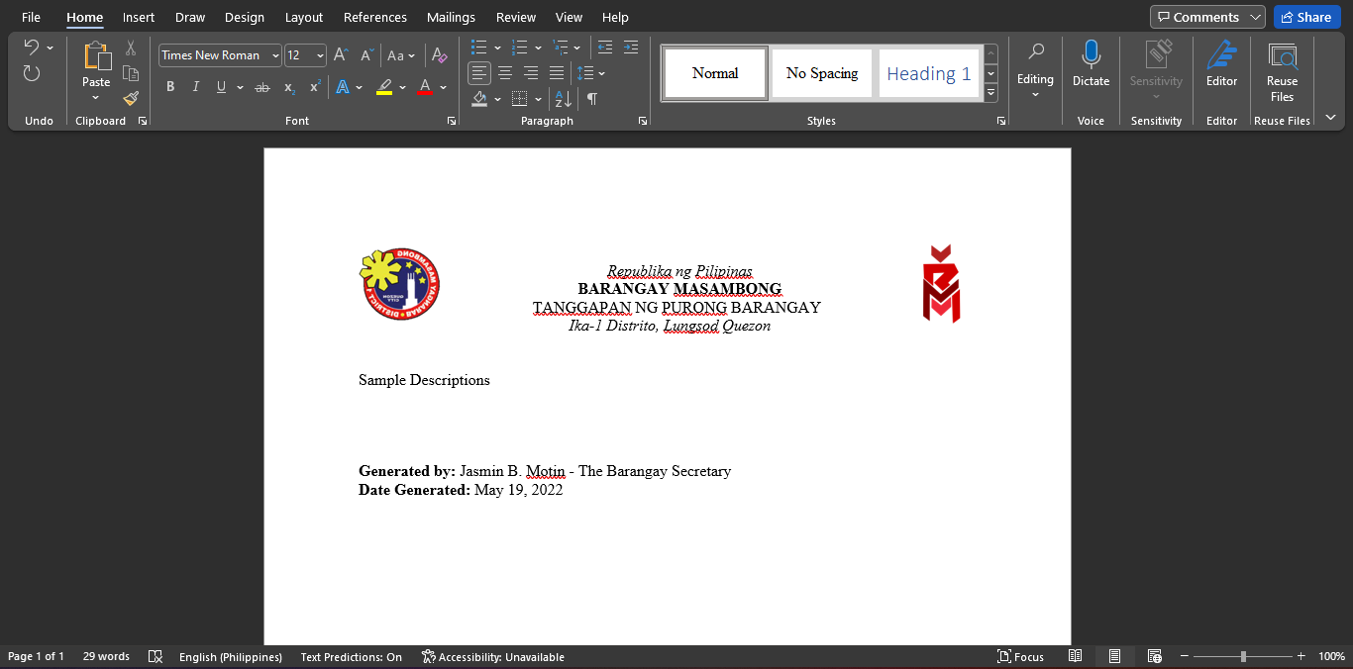

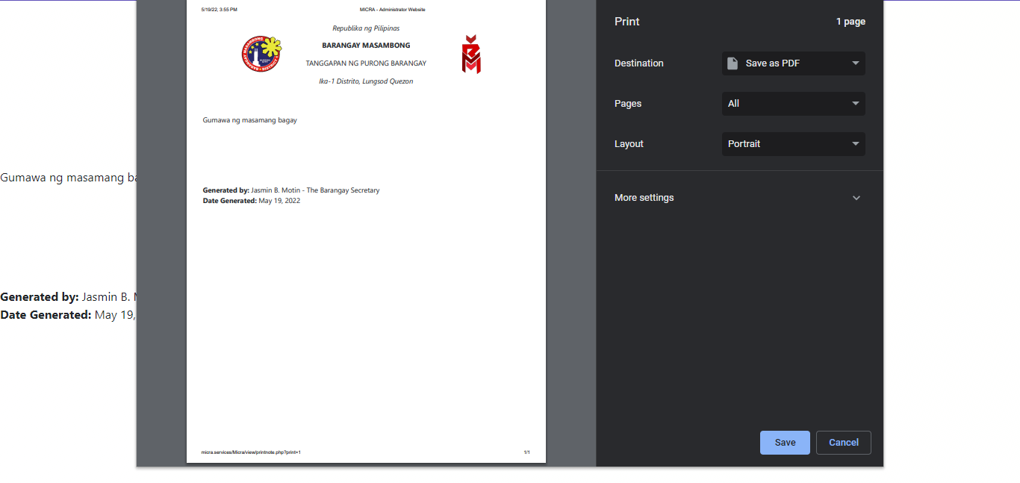

This is the view for the Print button.

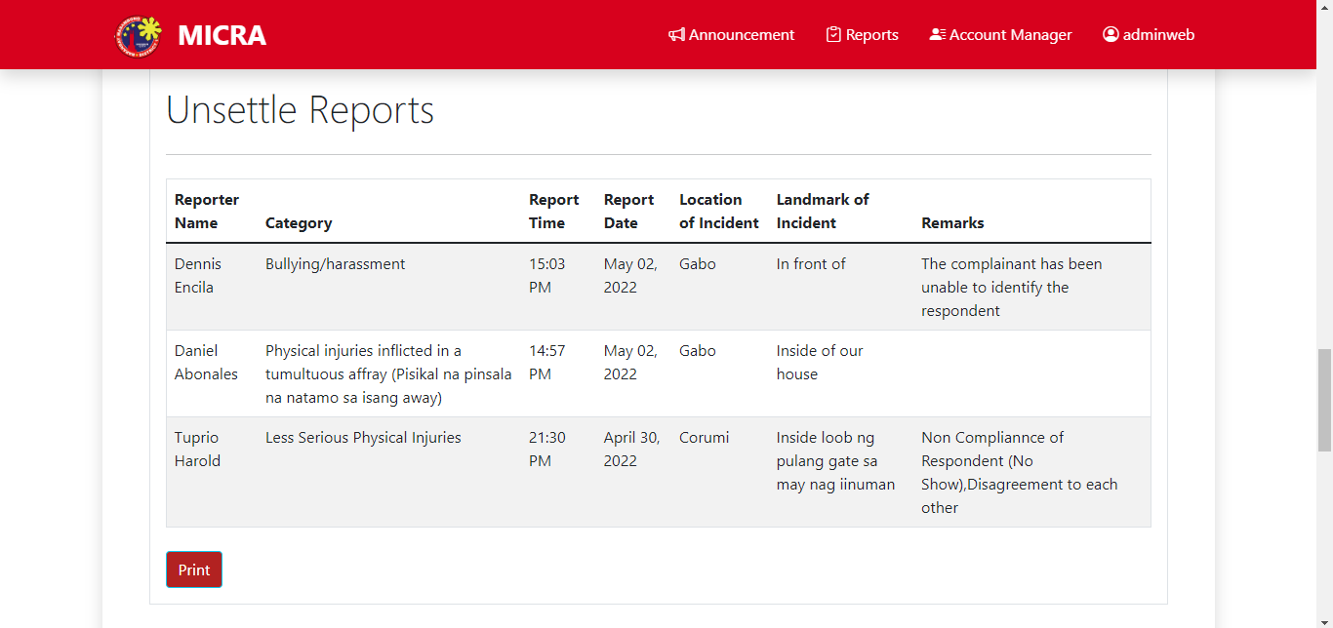

Head Admin Unsettled Report – The admin will see the Reporter Name, Category, Report Time, Report Date, Location and Landmark of the Incident, and lastly Remarks.

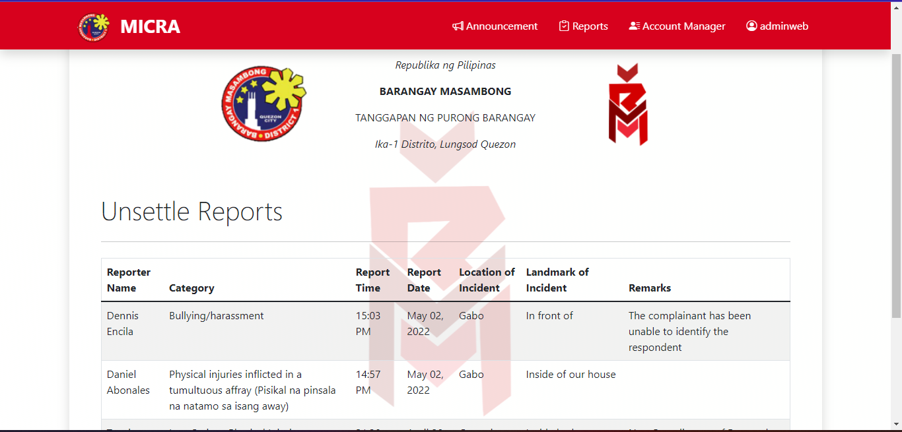

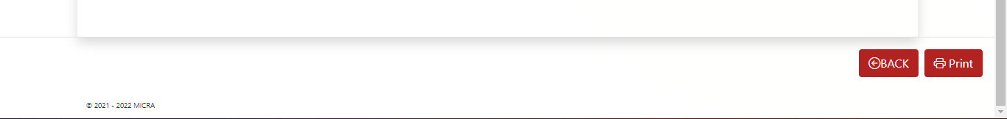

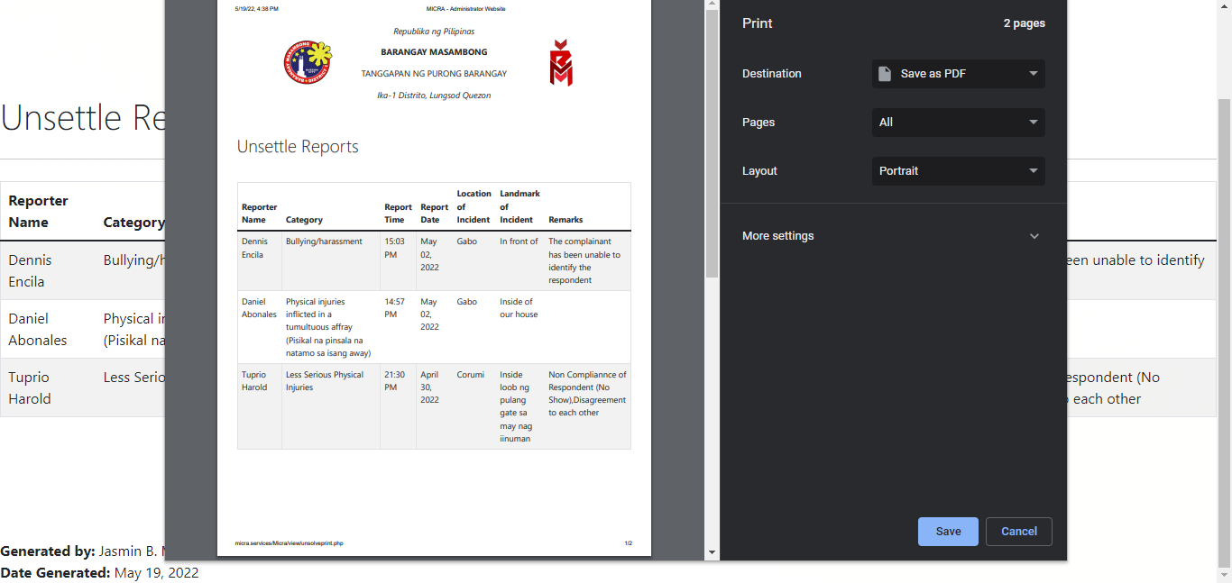

This is the view for the print button in Unsettled Reports.

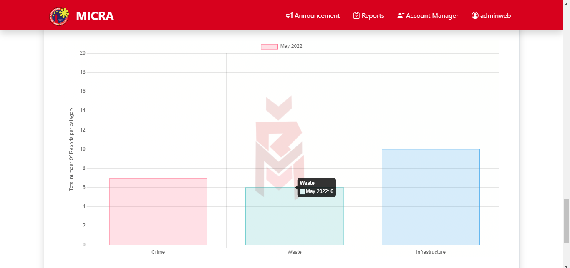

This is the view for total numbers of Report per Category.

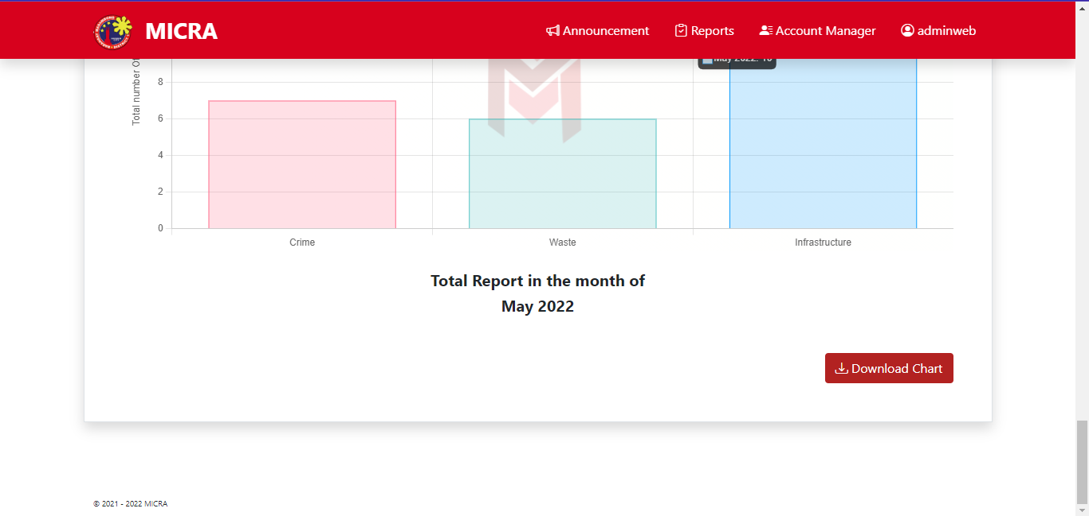

At the bottom of the chart they will see the Download Chart wherein you have your own copy of the chart.

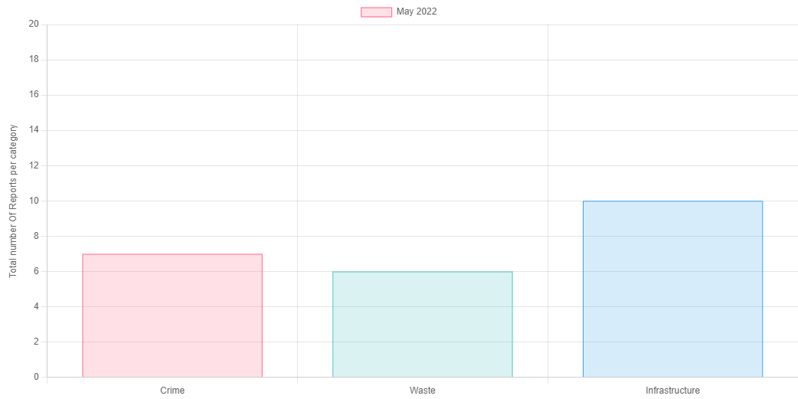

CHART DOWNLOADED

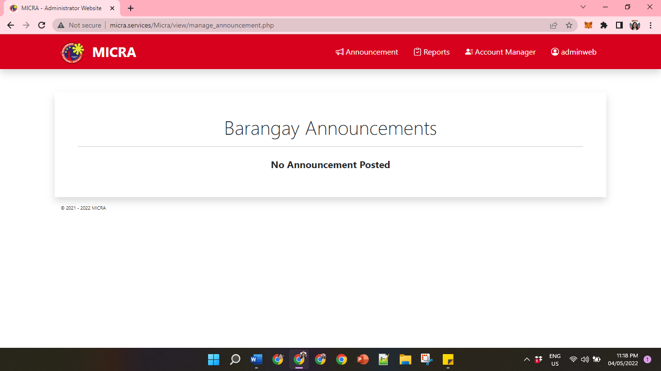

Head Admin Manage Announcement– The Head Admin will see the displayed announcement. The Head Admin Can Edit and Delete the Announcement.

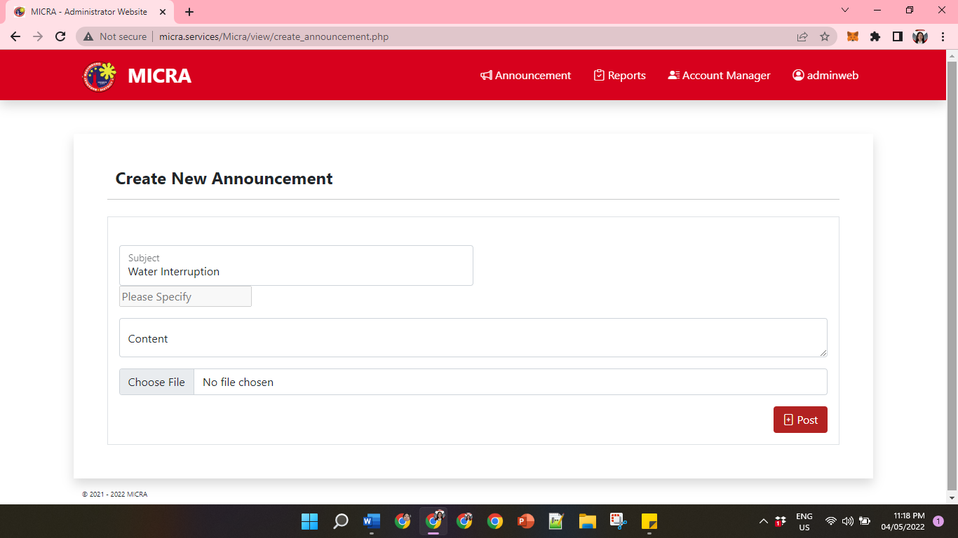

Head Admin Create Announcement– The Head Admin can create a Subject Title, Content, and can add a file/jpeg that can display in the Announcement Module. After this, the Head Admin can now post the Announcement.

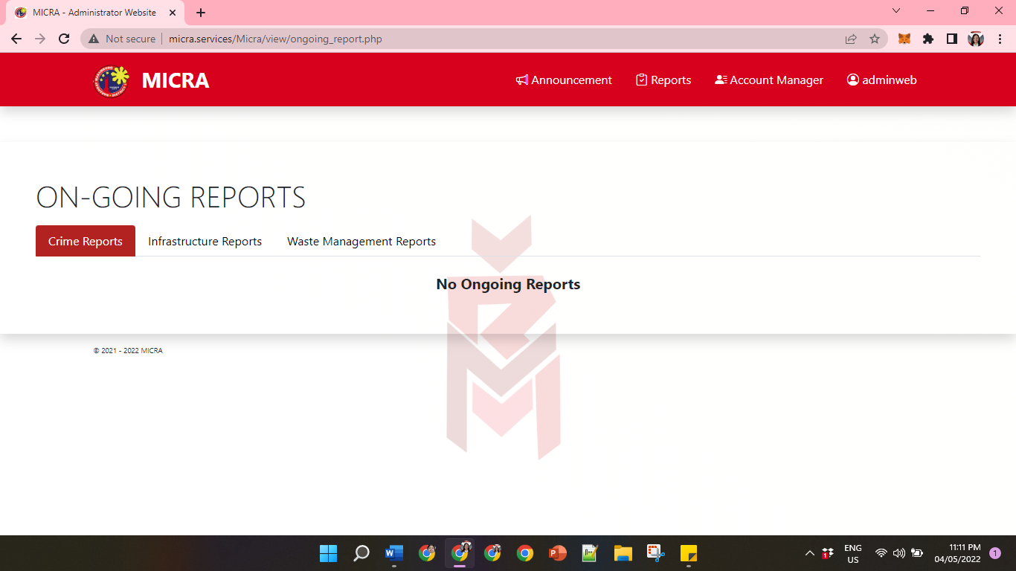

Head Admin Ongoing Reports for Crime Reports– The Head Admin will see the Report ID, Category, Report Date, and the Status of the Report.

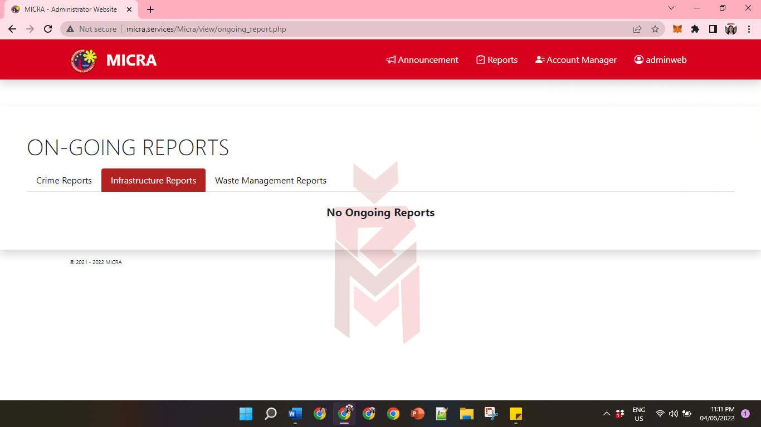

Head Admin Report Logs for Infrastructure – The Head Admin will see the Report ID, Category, Report Date, and the Status of the Report.

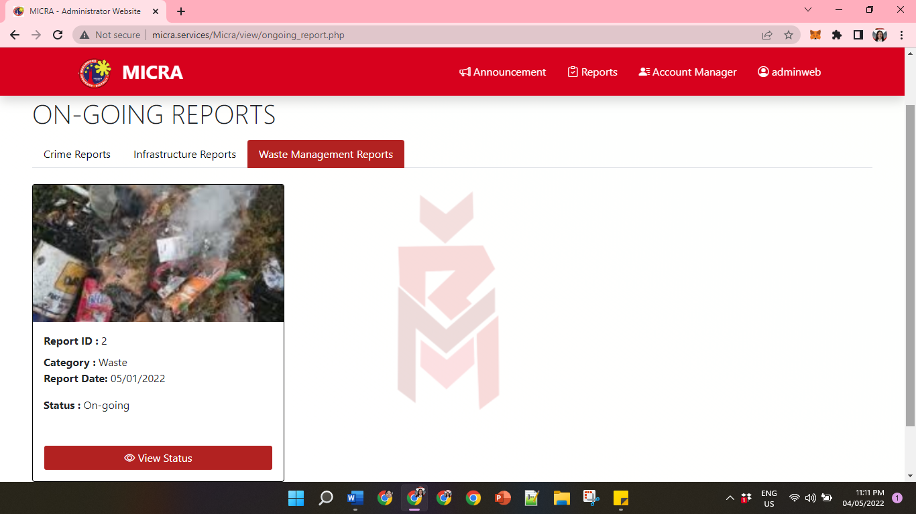

Head Admin Ongoing Reports for Waste Management – The Head Admin will see the Report ID, Category, Report Date, and the Status of the Report.

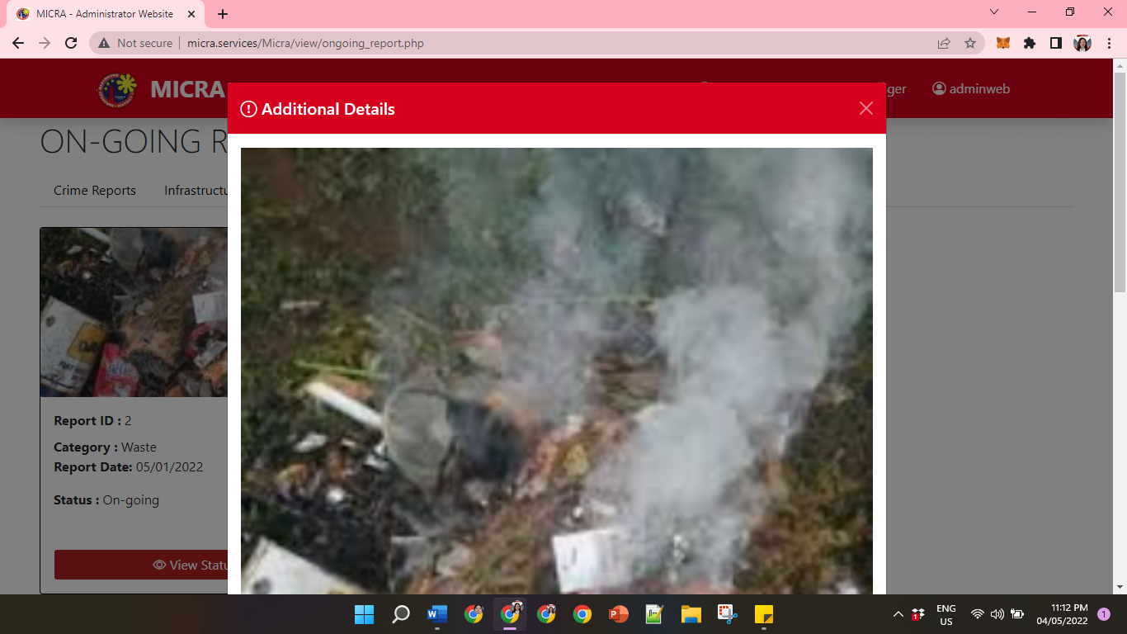

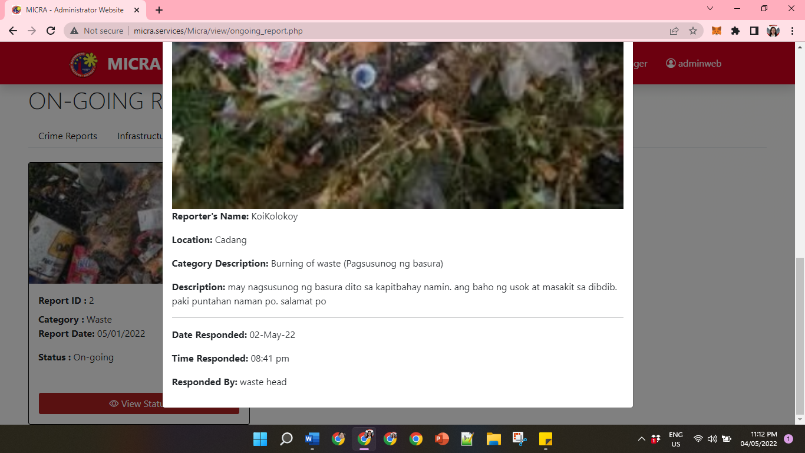

Head Admin Ongoing Reports for View Status

- The Head Admin can view the additional details of the report.

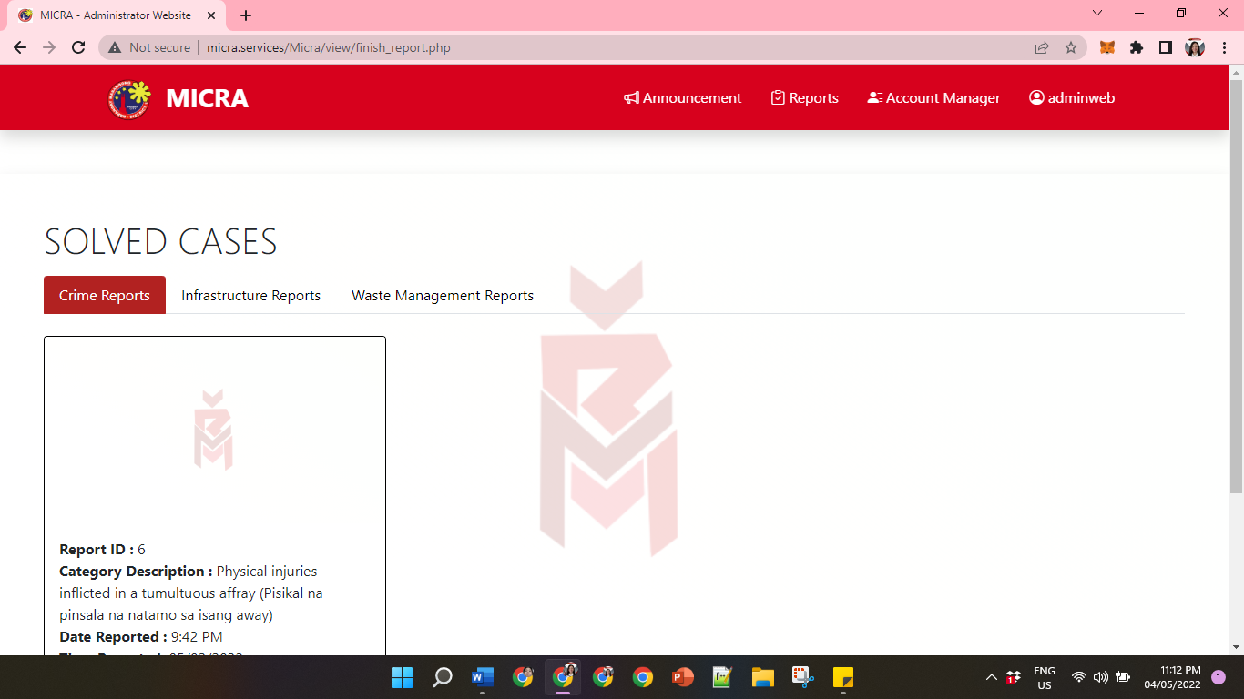

Head Admin Solve Cases for Crime Reports– The Head Admin will see the Report ID, Category Description, and the Status of the Report.

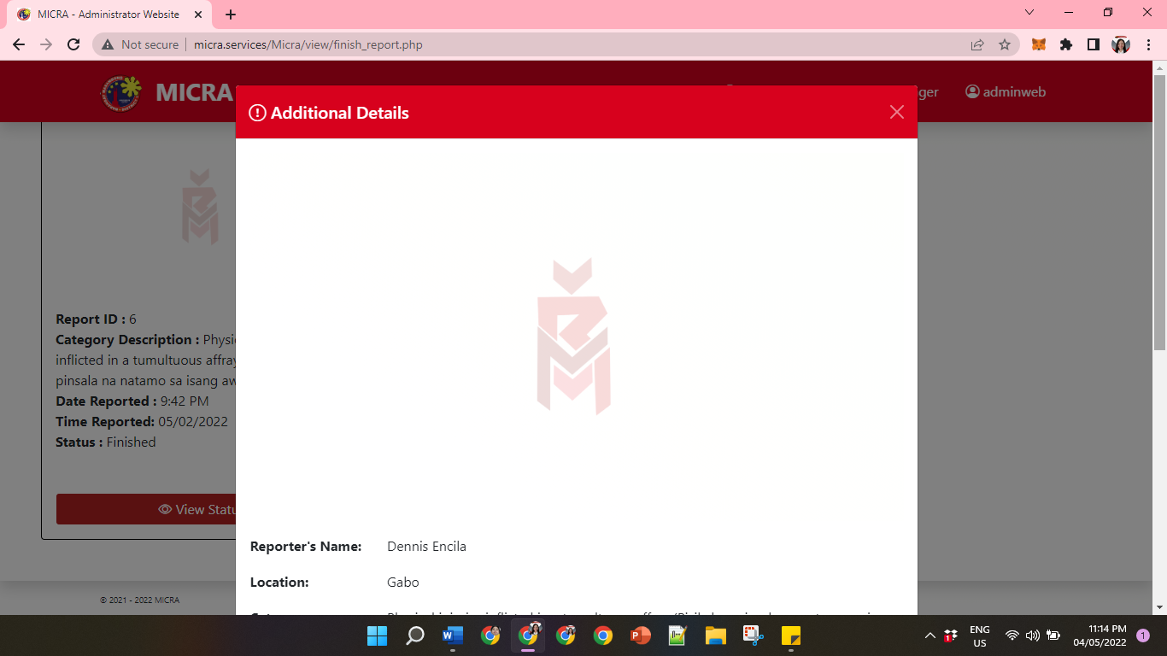

Head Admin Solve Cases for Crime Reports– The Head Admin will see the additional details of the report which are Reporter’s Name, Location, Category Description, Report Description, Resolve Date, Resolve Time, and Remarks.

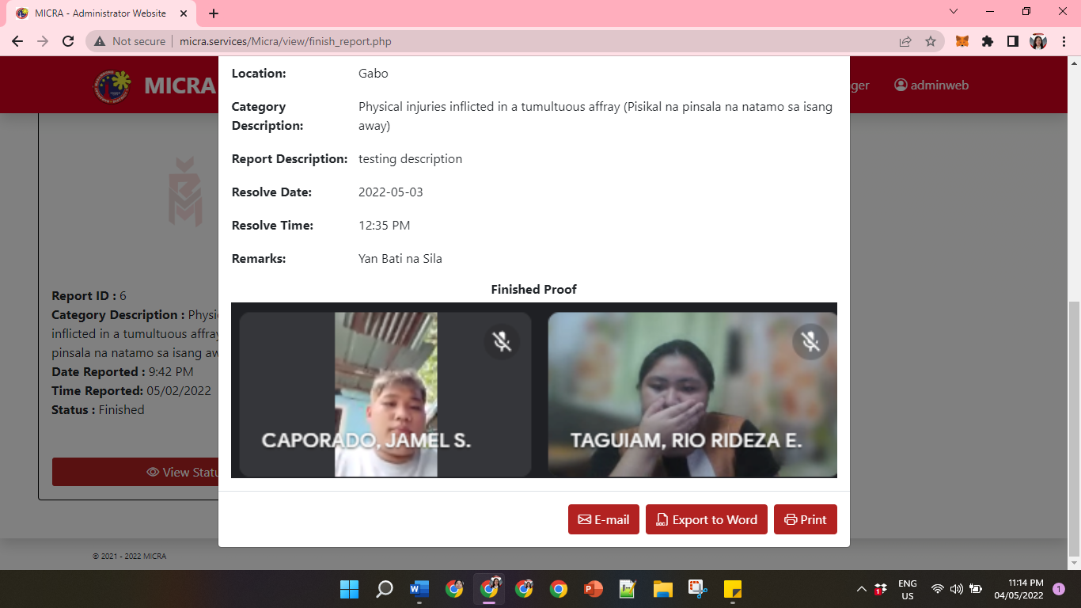

Head Admin Solve Cases for Crime Reports– There would be 3 text buttons for every report which are E-mail, Export to Word and Print.

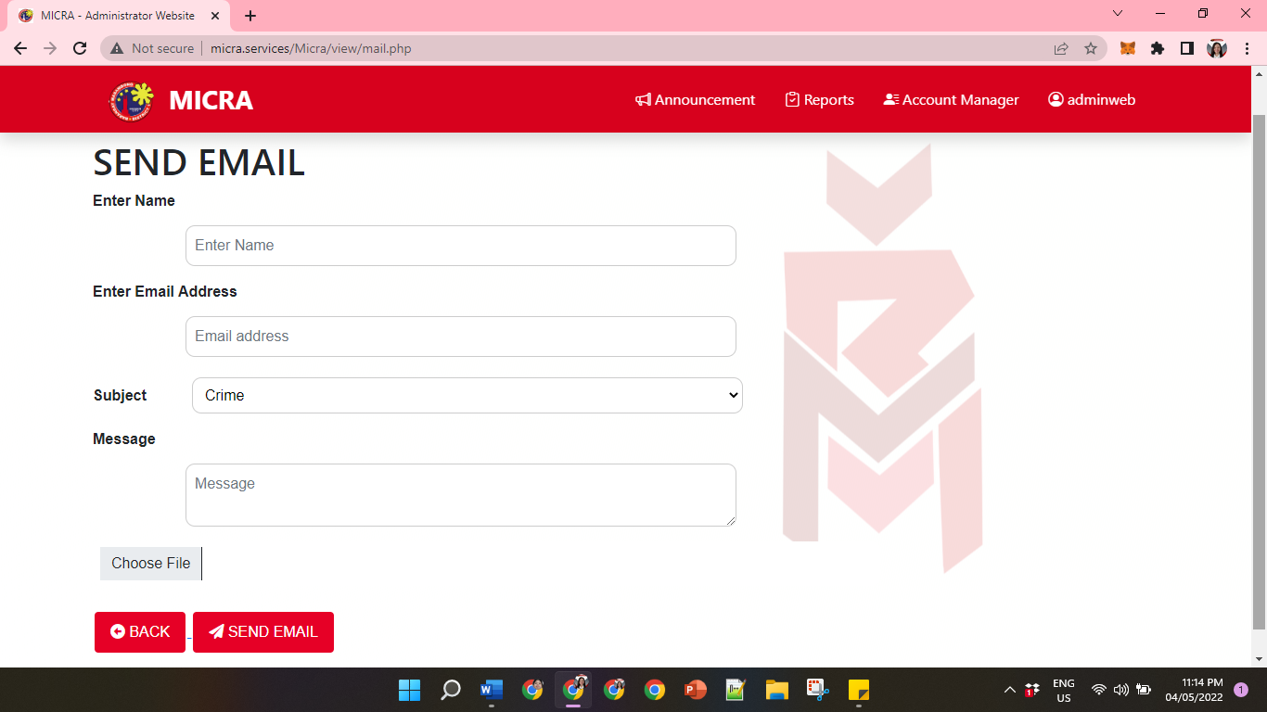

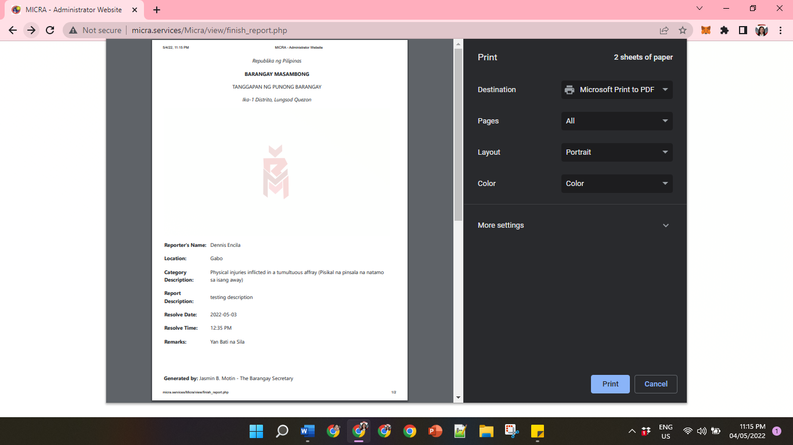

-

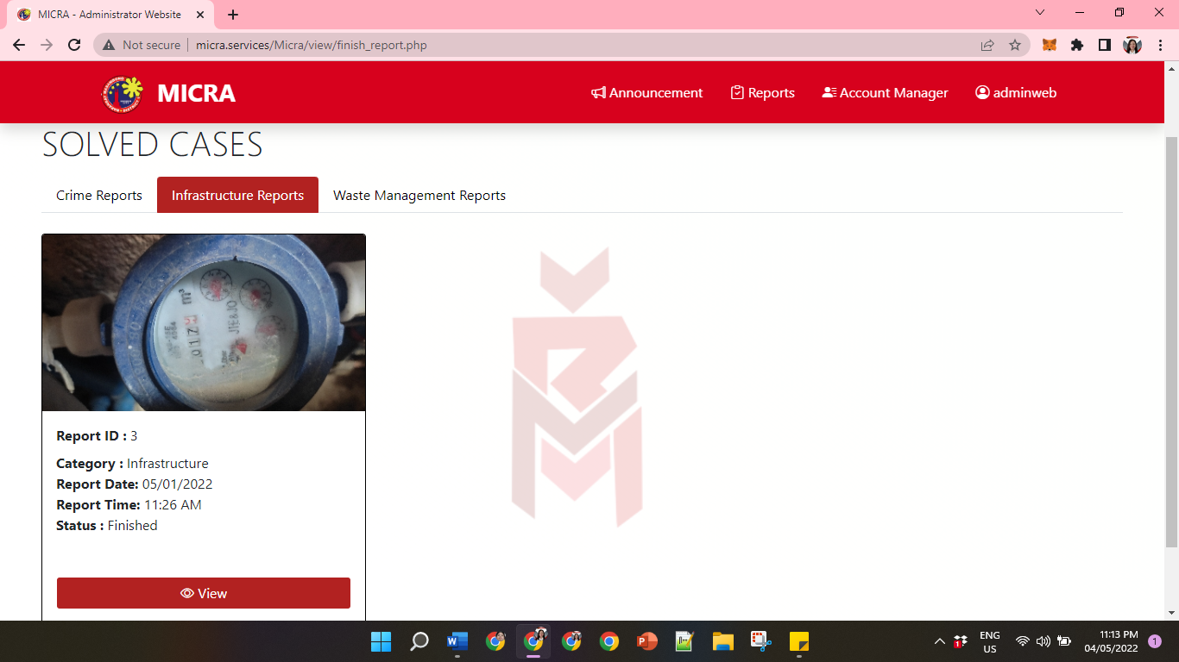

Head Admin Solve Cases for Infrastructure Reports– The Head Admin will see the Report ID, Category, Report Date, Report Time and the Status of the Report.

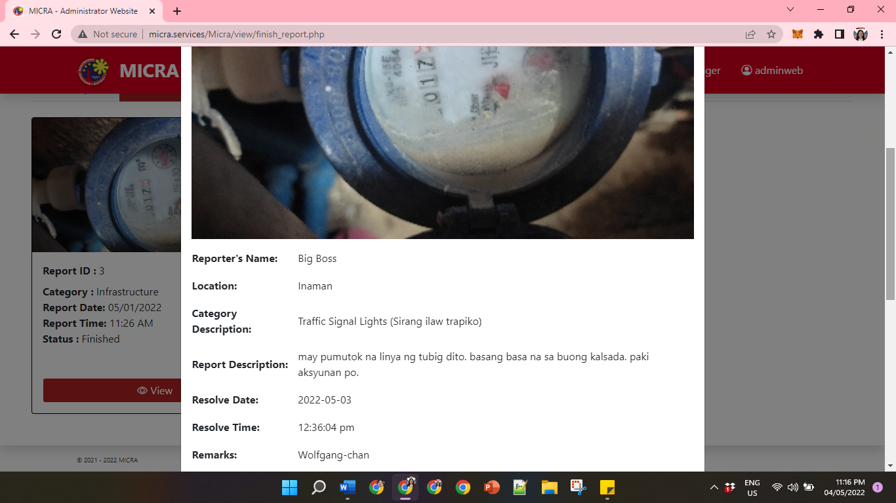

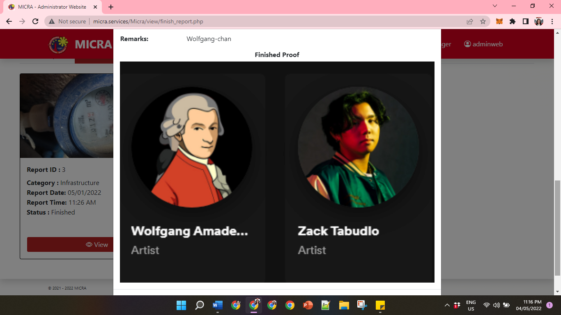

Head Admin Solve Cases for Infrastructure Reports – The Head Admin will see the additional details of the report which are Reporter’s Name, Location, Category Description, Report Description, Resolve Date, Resolve Time, and Remarks.



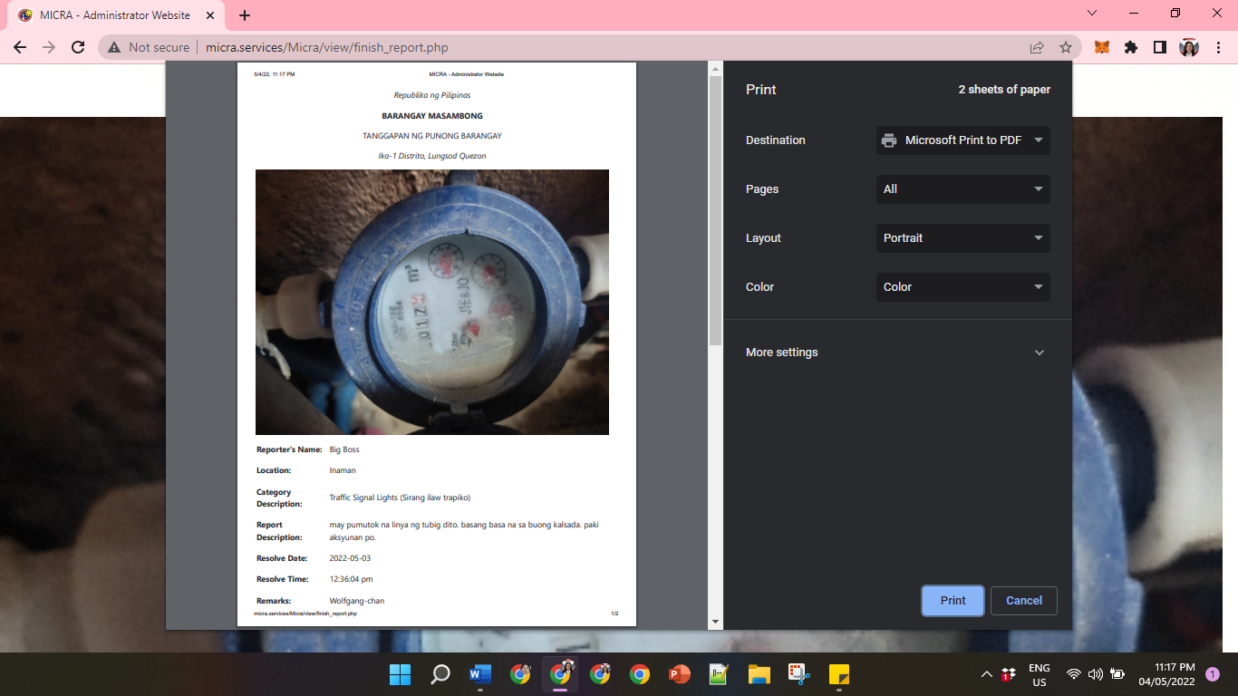

Head Admin Solve Cases for Infrastructure Reports– There would be 3 text buttons for every report which are E-mail, Export to Word and Print.

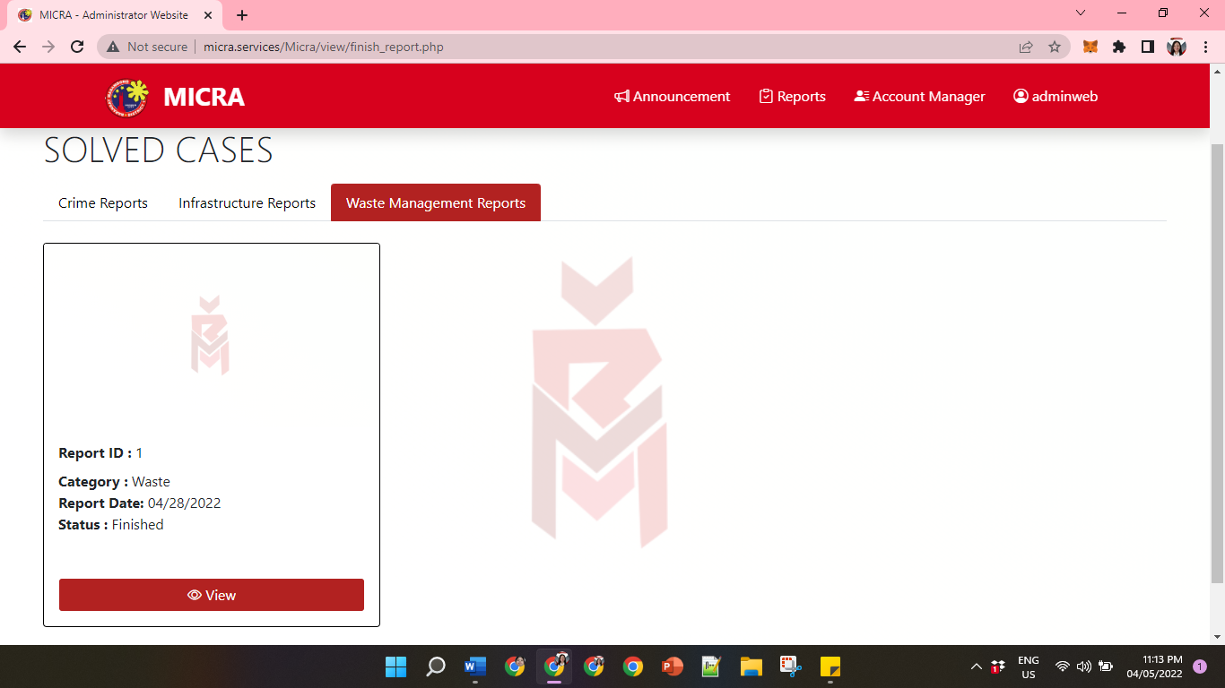

Head Admin Solve Cases for Waste Management Reports– The Head Admin will see the Report ID, Category, Report Date and the Status of the Report.

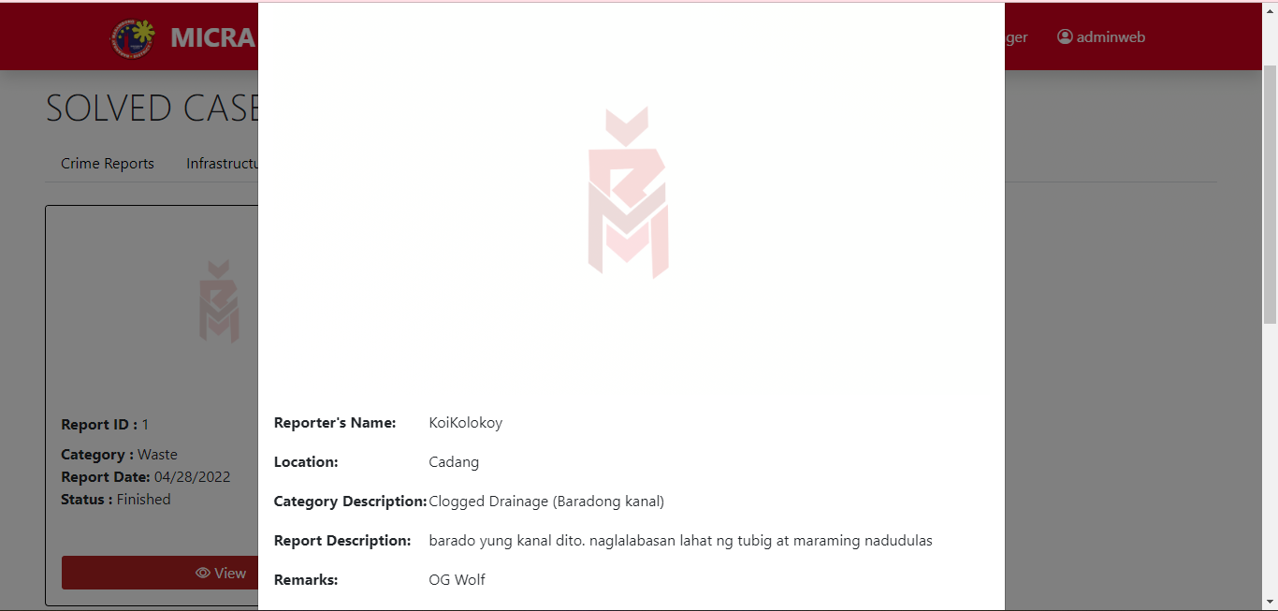

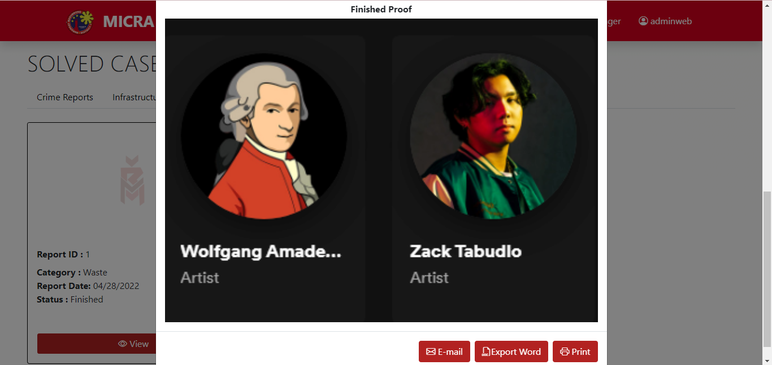

Head Admin Solve Cases for Waste Management Reports – The Head Admin will see the additional details of the report which are Reporter’s Name, Location, Category Description, Report Description, Resolve Date, Resolve Time, and Remarks.

And also the proof of the report.

And also the proof of the report.

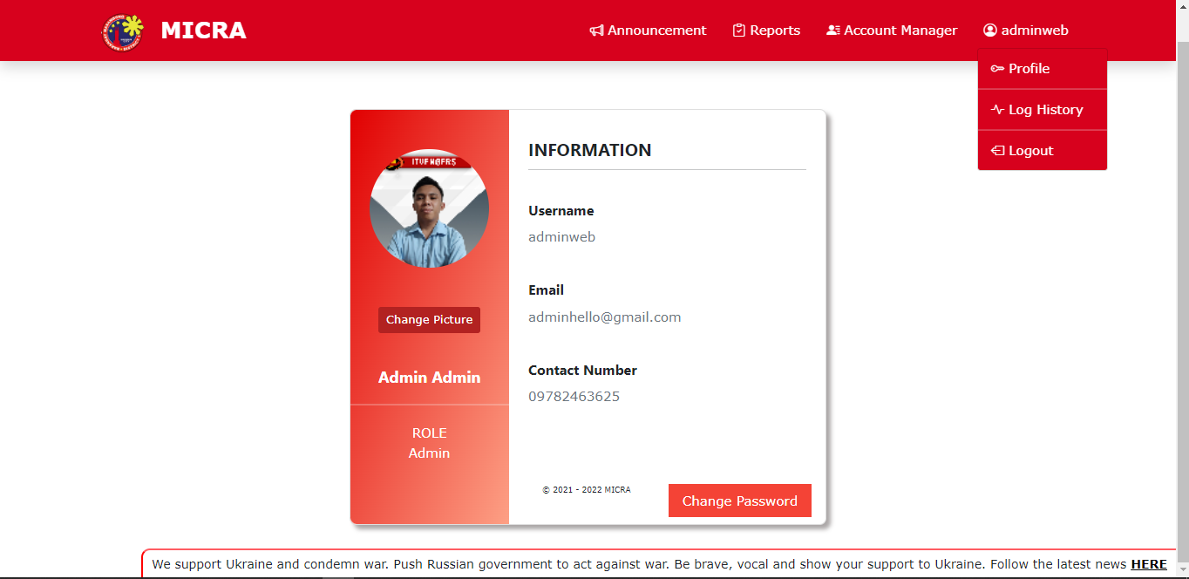

Head Admin Profile – The Head admin will see his/her account. The Head Admin can also change his/her profile picture, and click “Change Password” if the Head Admin wants to change his/her password.

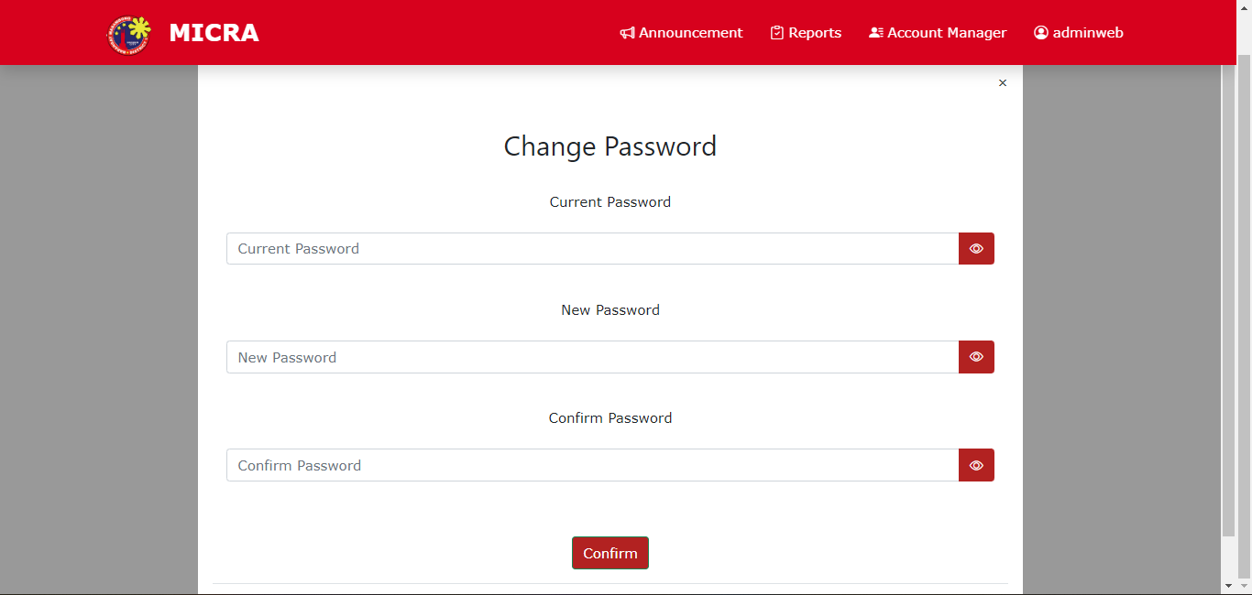

The Head admin will see the module for changing password.

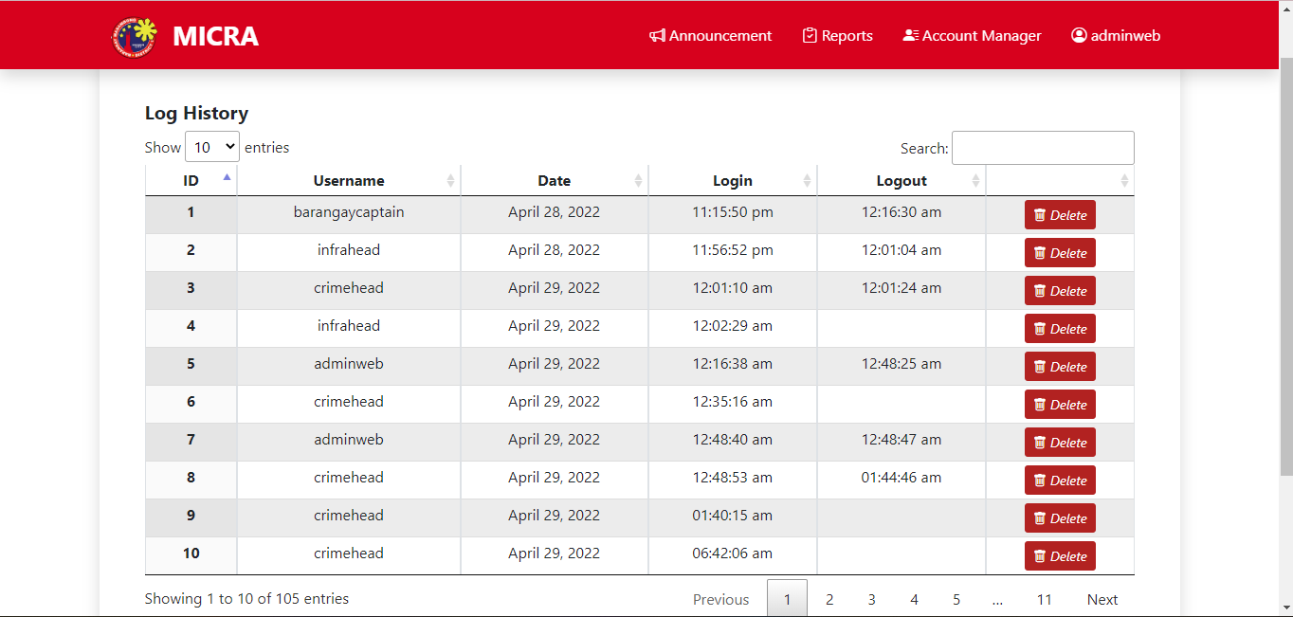

Head Admin Log History – The Head admin will see the login and logout accounts of head admins. The Head Admi can also clear the Log History and can delete specifically.

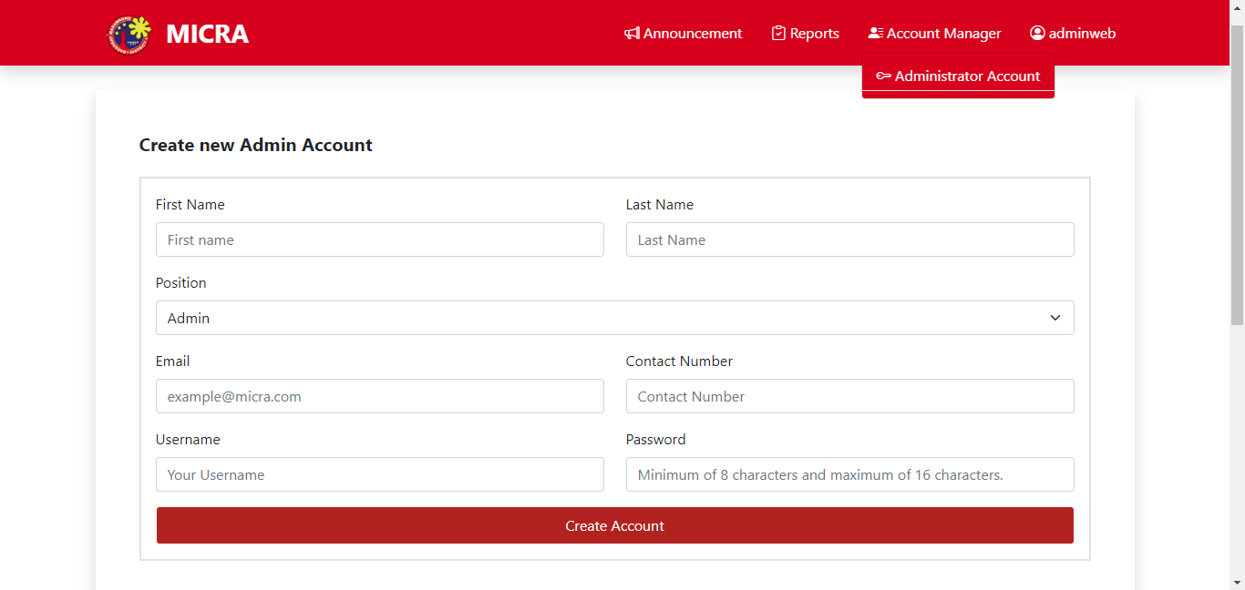

Head Admin Administrator Account – The Head Admin can create a new admin account. The Head Admin must fill up first the following. If the Head Admi done inputted information, click create account.

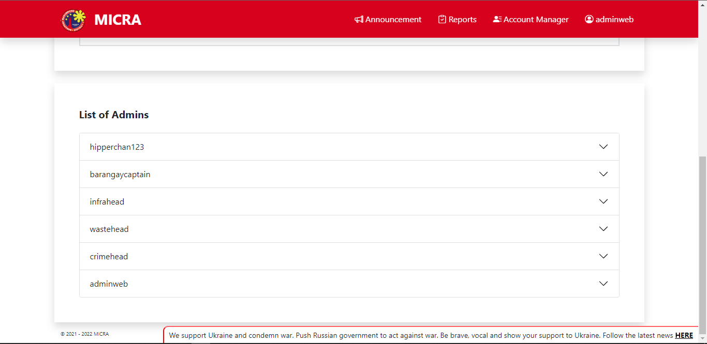

Head Admin List of Admins – After the head admin created an account, the admins account will display.

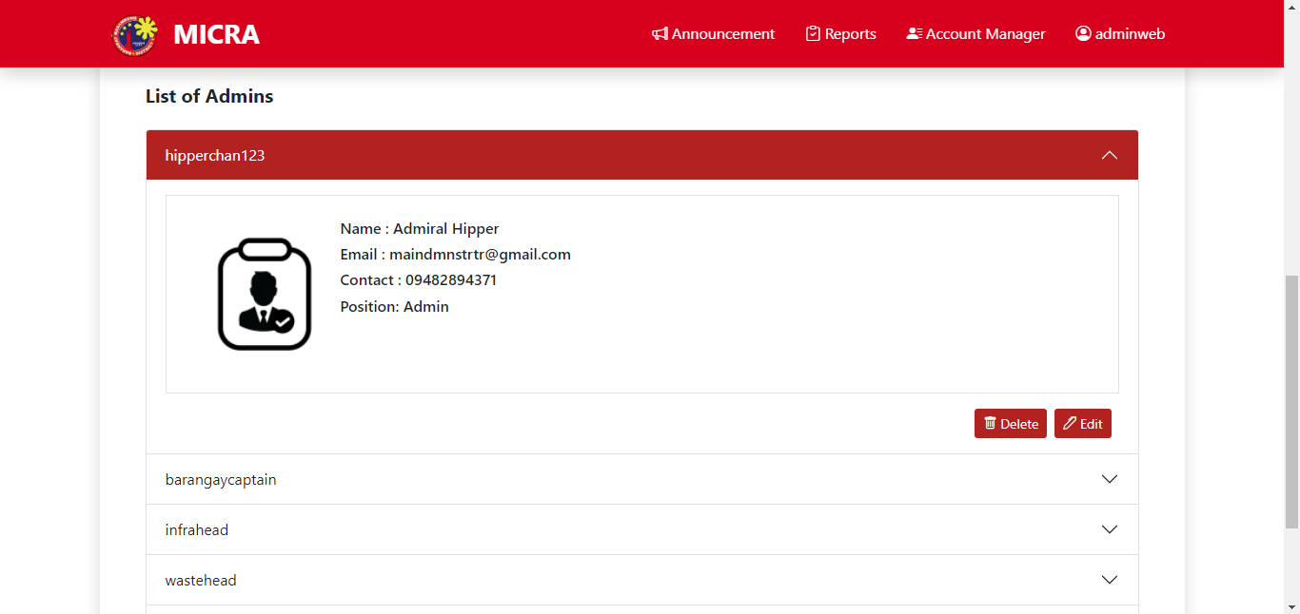

Head Admin List of Admins – After you click the admin you will see Delete and Edit.



Head Admin Ongoing Reports for Crime Reports– The Head Admin will see the Report ID, Category, Report Date, and the Status of the Report.